Wireless Mouse
Enjoy wireless freedom with total optical accuracy for all your devices
Stylish in design, comfortable in use with accurate control
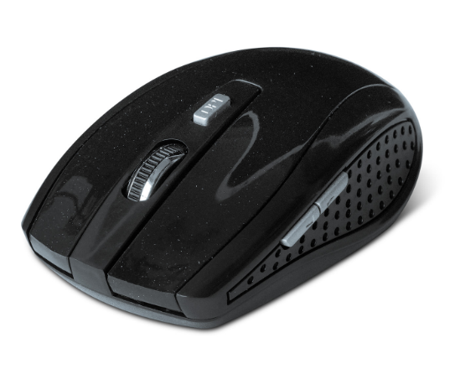

Descrption:
Freedom from wires, wherever you want

No more messy USB mouse cables. With the supplied wireless USB transceiver you can enjoy total freedom and total accuracy.

HD optical tracking

Enhanced 800dpi/1200dpi/1600dpi LED tracking gives superior on screen control for both office and gaming applications. Works on almost any surface too.
Comfortable, natural control with less strain
Carefully designed for both left and right-hand users with a more natural grip. Full, three-button technology with central scroll-wheel for easy navigation.

Control all your devices
Ideal for WindowsTM computers, notebooks, desktops and servers with any avaliable USB port.

Features:

Optical, Wireless Mouse, 6D 5-Buttons + scroll wheel

Supplied with a 2.4GHz wireless nano USB adapter

High-resolution, selectable 800/1200/1600 DPI

Clutter-free, wireless transmission up to 10 metres approx

Plug n’ play, no drivers needed for all popular OS

Ideal for Windows(tm), Mac OS X (tm), Linux(tm)

Ideal for Raspberry PI(tm), Android (tm)

Requires 2 x AAA (Not Included)

Specifications
- Working Principle：2.4Ghz Radio Frequency
- CPI Button：800/1200/1600 CPI adjustable
- Buttons：Left, Right, Wheel and CPI
- Working Range：Max 10 Meters
- Wheel：1 Scrolling Wheel
- Power Consumption：3V DC 15mA
- Certificate: CE FCC ROHS
- Operating Temperature:0℃ to +45℃
- Operating Humidity:10%0 to 85 % RH
- Storage Temperature : -10℃ to +55℃
- Storage Humidity: 5% to 90 % RH

Product Code:
Part number: M140W
Barcode: 84008000381171
Size: 10.7x7x.3.8 cm
Weight: 0.111 kg

